
DJ • BROADCASTER • PERFORMANCE ARTIST
LONDON, UK
OFFICIAL DJ - WORLD NAKED BIKE RIDE LONDON 2026 AFTERPARTY
OPENING NIGHT PERFORMER - EROTIC ART LONDON 2026
“We spend our lives presenting constructed versions of ourselves, but underneath we're all just ordinary people. Sometimes we need to be reminded.”

Hero Shot | Performance Shot 1 | 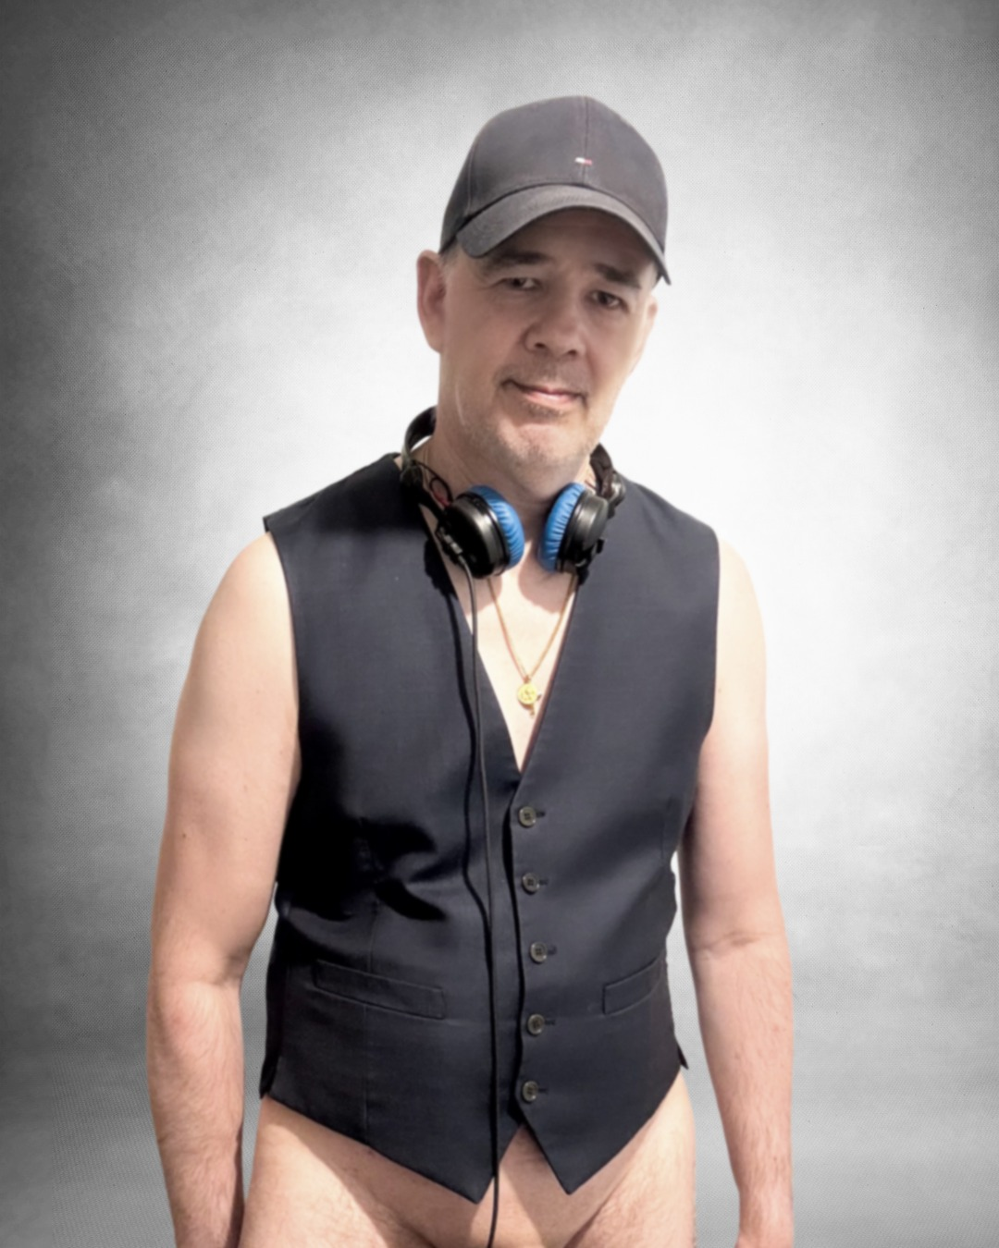  Performance Shot 2
High resolution files available on request. All images cleared for press and editorial use.
ABOUT
DiskoStick is a London-based DJ, broadcaster and music producer with over thirty years of professional experience spanning live events, television, radio and music production. His work is rooted in a simple but deeply held belief: that we spend too much of our lives hiding behind clothes, behind carefully constructed versions of ourselves and that the dancefloor, at its best, is one of the few spaces where that stops mattering.
DiskoStick is the official DJ of the World Naked Bike Ride London 2026 afterparty and performed on the opening night of Erotic Art London, two of the most prominent body-positive and clothing-optional events in the UK cultural calendar, with both already confirmed to return in 2027. He is among the first DJs in the UK to build a sustained public identity around body positivity and self-acceptance, performing across clothing-optional, naturist and body-positive environments as a deliberate expression of those values.
Rooted in the golden era of disco reimagined through contemporary rework culture, DiskoStick delivers musically intelligent, groove-focused sets that balance the warmth of the originals with a modern dancefloor sensibility. Expect the elegance of classic Philly alongside the joyful campness of Gloria Gaynor and ABBA, music that celebrates, connects and moves people.
DiskoStick performs live re-edits as a constant and natural part of every set, drawing on an extensive library to create combinations that exist only in that room, on that night. Vocals from one recording placed over basslines from another, melodies layered over a different groove, original percussion added live in response to the room. Every performance is, in that sense, an exclusive.
The visual identity, waistcoat on bare skin, baseball cap, is deliberately understated. It is not costume, not spectacle. It is simply someone who has stopped hiding, doing what they do best. This signature emerged through the critically recognised DiscoExposed art project, exhibited at the London Contemporary Art Show, Hoxton, and is now the permanent foundation of every DiskoStick performance.
The personal story behind it all, why the exposure, what it means, and what it took to get there, is told in full on the dedicated Behind the Mask page at diskostick.com.

TWO FORMATS, AGREED IN ADVANCE
DiskoStick performs in two formats, agreed in advance to suit the venue, audience and context. There are no surprises, the conversation about format is always openly held at booking stage.
Community
The default presentation, suitable for mainstream and public events.
Conceptual
Full visual signature, with exposure adjusted to match the cultural norm of the room. For clothing-optional, naturist and body-positive environments where DiskoStick's values are fully embodied in the space itself.

BROADCAST & PROFESSIONAL CREDENTIALS
- Television broadcast work across multiple productions and formats
- Radio presenting and production, spanning commercial and specialist programming
- Live event DJ work across venues, festivals and private engagements
- Music production, studio work and live re-editing
- Official DJ, World Naked Bike Ride London 2026 Afterparty - confirmed booking for 2027
- Opening Night Performer, Erotic Art London, Copeland Gallery, Peckham (2026) - confirmed return 2027
- Exhibition at the London Contemporary Art Show, Hoxton (2026)

DISCO AS A LIVING LANGUAGE
DiskoStick plays disco. Not as nostalgia, but as a living musical language that remains one of the most joyful, inclusive and dancefloor-functional forms ever created.
Sets draw from the rich heritage of 1970s and 1980s disco, brought into the present through the work of leading rework producers. The sound is warm, groove-focused and broadly accessible. It makes people dance. This musical identity is particularly well suited to clothing-optional, body-positive, LGBTQ+ celebratory and outdoor festival environments, where the emotional register of disco culture — joy, freedom, solidarity, defiant pleasure, aligns directly with the values of the event.
Suited To
- Body-positive and clothing-optional events and festivals
- LGBTQ+ celebratory events, Pride fringe and community nights
- Naturist community events, resort socials and member gatherings
- Kink-social and sex-positive spaces where music is the focus
- Outdoor daytime and evening festival stages
- Gallery and cultural late night events
- Immersive and performance art environments
- Selected mainstream brand, private and broadcast engagements where values alignment exists

GET IN TOUCH
General enquiries, venues, events and promoters — get in touch directly by email or social media.
Email: hello@diskostick.com
Website: www.diskostick.com
Instagram: @disko.stick
TikTok: @djdiskostick
X: @djdiskostick
Mixcloud: diskostick
Private bookings: via website
Press images supplied at high resolution for print and digital use on request.
DiskoStick • London 2026

